Function Spaces & Fourier Series

Fourier Series Problem Set

Team:

Carpe Noctem

Team Leaders:

Michael Sangillo

Team Members:

Carlos Lazo, Christopher Rappa, Jake Tisdale, Michael Sangillo

Course: TDC1

Instructor: Glenn Berger

Group Hours: 15 hours

Date Submitted: 11/24/08

PROBLEM # 1

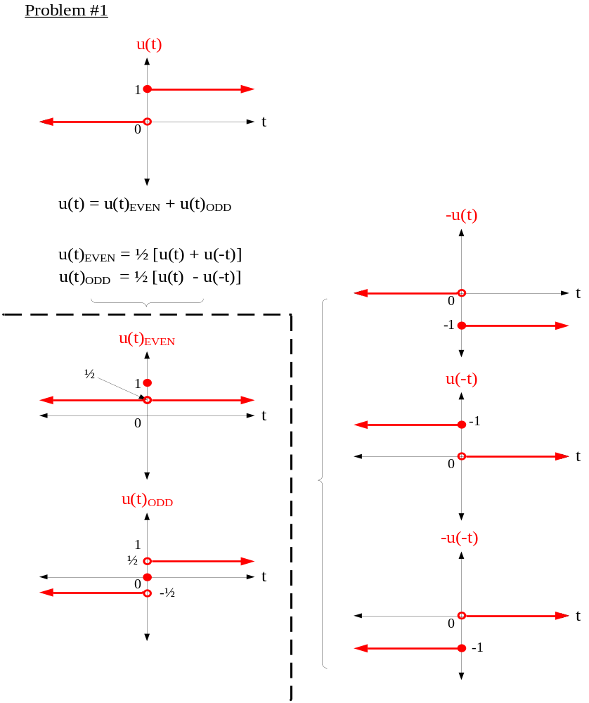

PROBLEM # 2

** Part A **

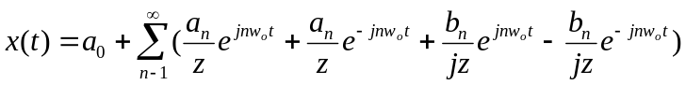
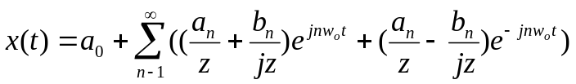
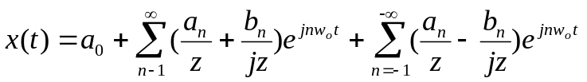
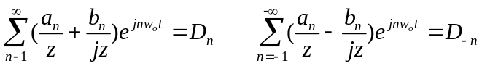

For real 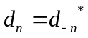 see part b for proof
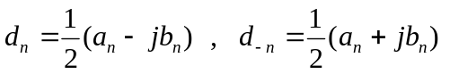
Even: 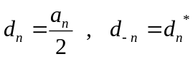
Odd: 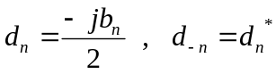

** Part B **

If real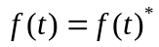
For all t,
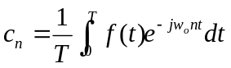
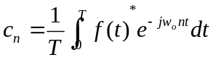
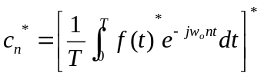
Substitute “n” for “–n”
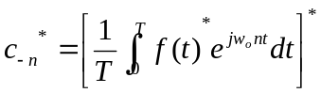
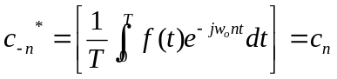 QED
PROBLEM # 3

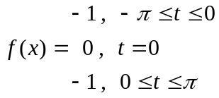

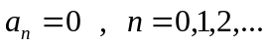
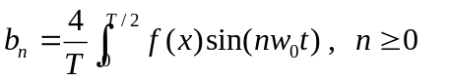
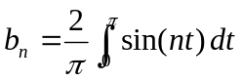
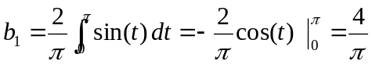
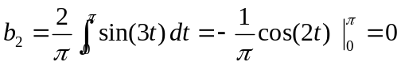
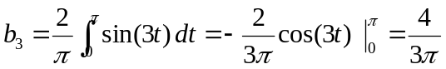
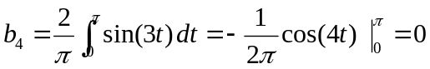
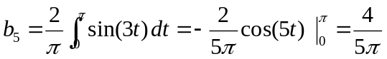
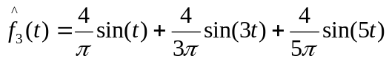
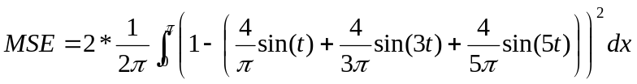
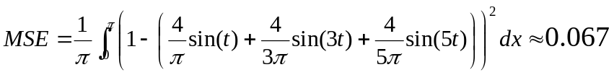

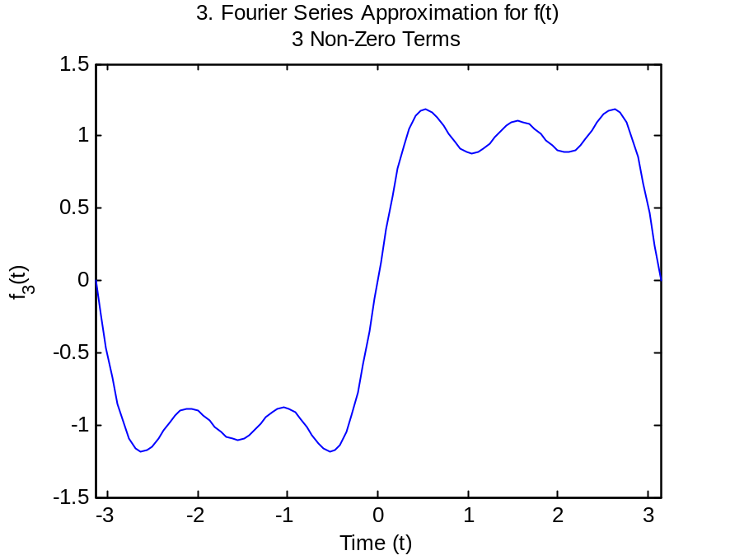

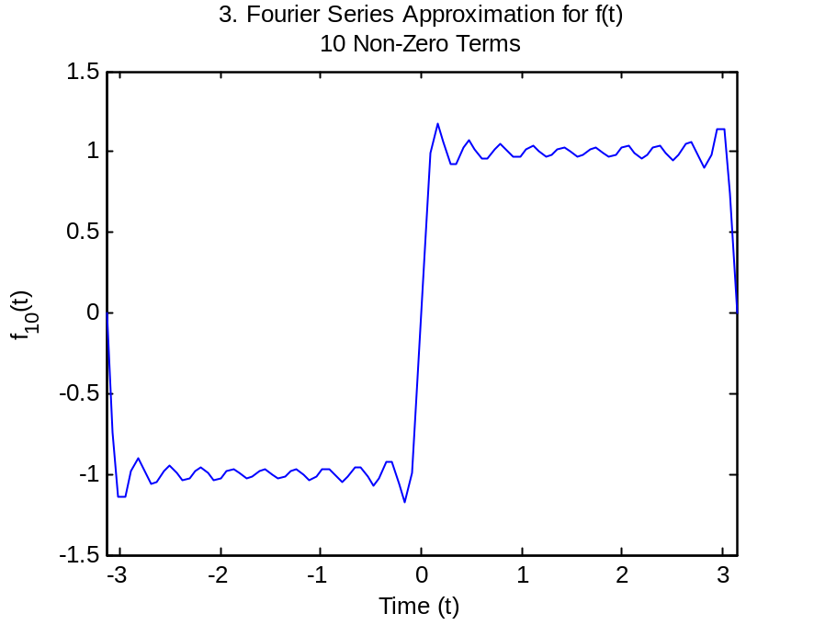

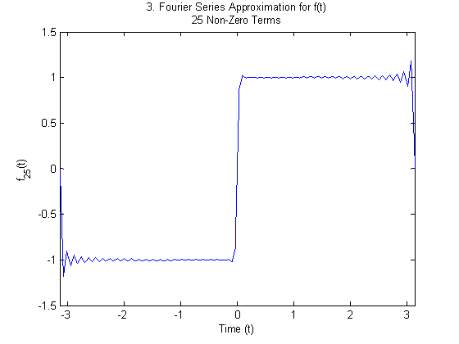

PROBLEM # 4

** Part A **

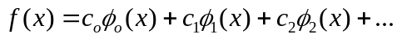
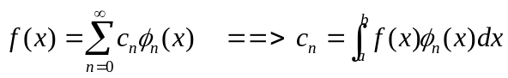
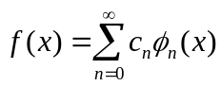
Integrate both sides over [a,b]:
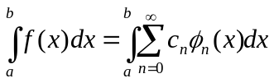

Multiply by some orthogonal function with fixed integer iteration (φ_{m}(x)):
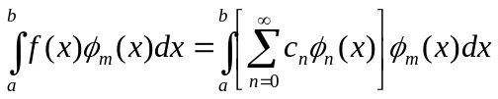

Distribute integration:
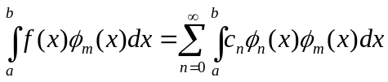

Substitute orthogonality relationship (from Mathworld):
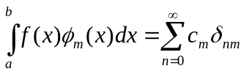

Evaluate summation:
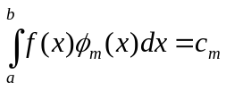

Substitute n=m:
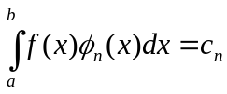
QED

** Part B **

We first state some preliminary definitions:

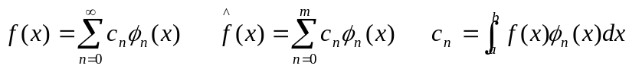
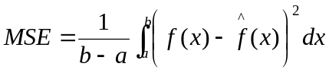

We then replace our estimate with its definition, and rewrite f(x) in terms of a series.

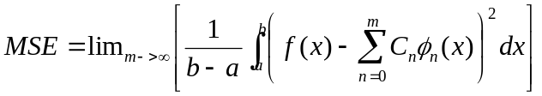
By taking the limit as our estimate m approaches infinity, our approximation essentially becomes our function f(x). In other words, the more C_{n} terms that exist, the less the error will be.

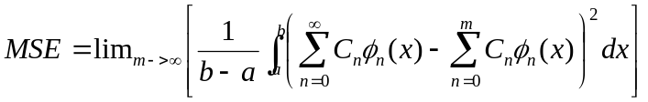
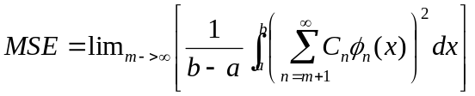

Now that the exact function and the error are equal, the value of the integral itself is zero. This does, in fact, minimize the mean squared error.

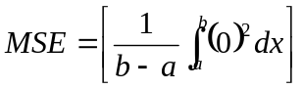
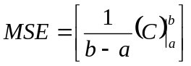
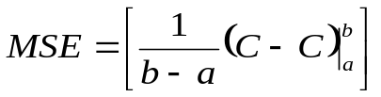
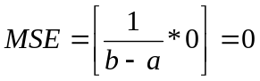

QED.
PROBLEM # 5

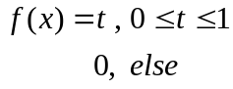
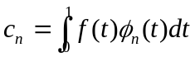
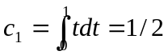
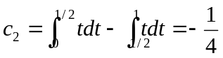
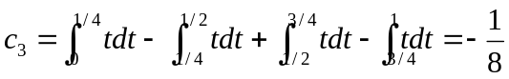

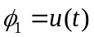
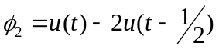
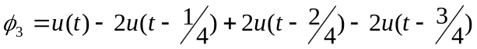
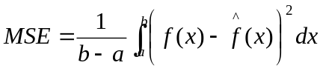
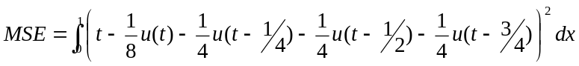

PROBLEM # 6

** Part A **

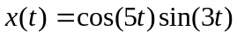

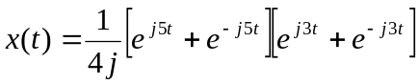
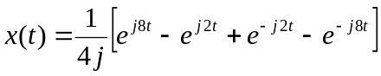 * j/j →
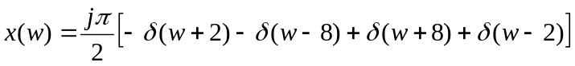

** Part B **

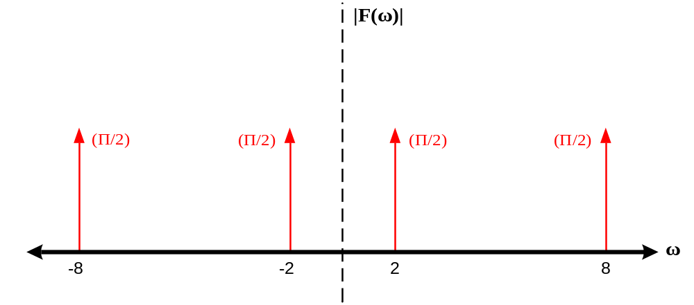

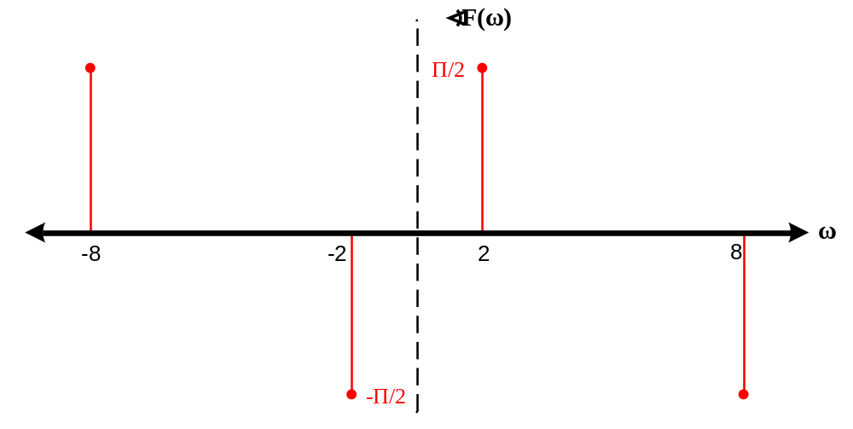

** Part C **

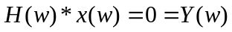

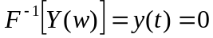

QED.
PROBLEM # 7

** Part A **
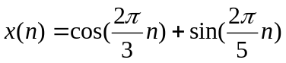
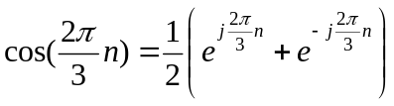
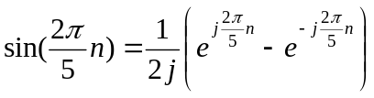

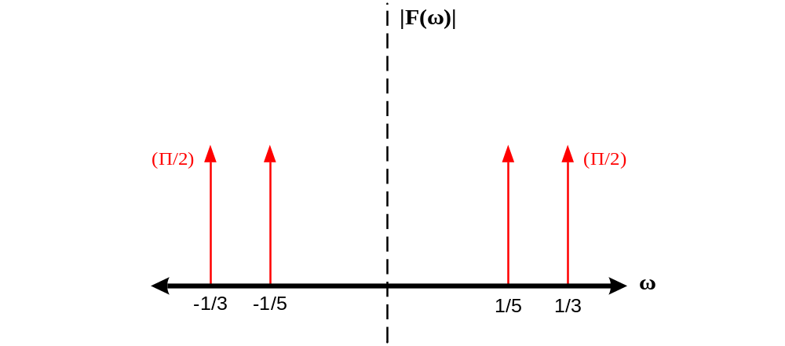

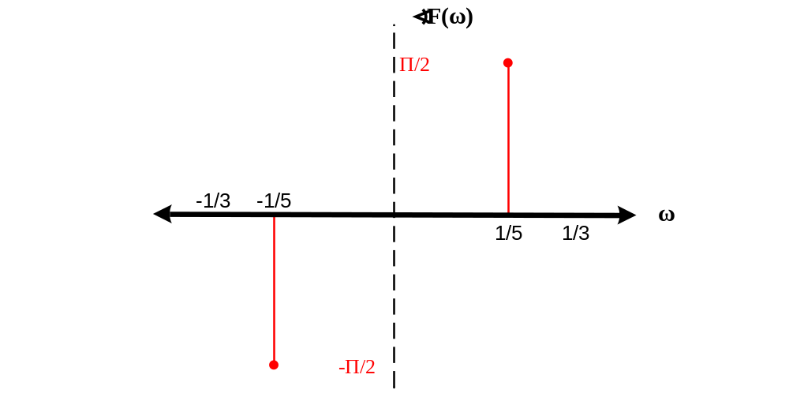
Fundamental Period:
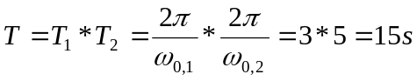

** Part B **

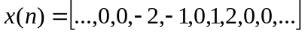
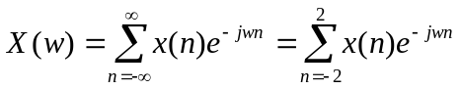
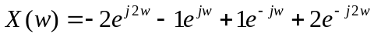
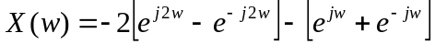
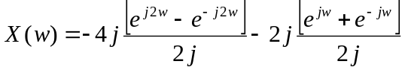
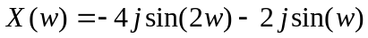
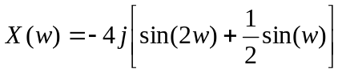

QED.

